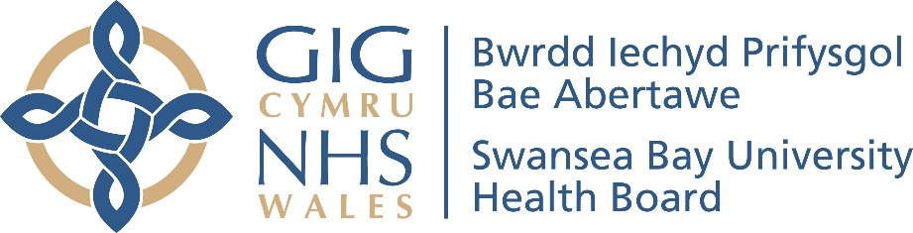
Newid dros dro i oriau agor Uned Mân Anafiadau Castell-nedd Port Talbot

Oherwydd pwysau staffio parhaus rydym wedi gwneud y penderfyniad anodd i gwtogi dros dro oriau agor yr Uned Mân Anafiadau yn Ysbyty Castell Nedd Port Talbot.
Mae bellach ar gael rhwng 8yb a 9yp, saith diwrnod yr wythnos, am gyfnod o naw mis, yn hytrach na'r amseroedd blaenorol, sef 7.30yb-11yp.
Bydd gennym staff ar gael o amgylch ardal yr Uned Mân Anafiadau a all ailgyfeirio unrhyw un sy'n dod rhwng 9yp ac 11yp.
Dylai unrhyw un sydd angen sylw brys na all aros tan y diwrnod canlynol ddefnyddio 111 neu, os yw'n ddigon difrifol, yr Adran Achosion Brys yn Ysbyty Treforys.
Mae'r Uned Mân Anafiadau yn rhan bwysig o wasanaethau brys a gofal brys Bae Abertawe. Nid oes gennym unrhyw fwriad i wneud hyn yn newid parhaol ac rydym yn recriwtio staff ychwanegol.
Rydym yn gweithio’n agos gyda Llais, y sefydliad annibynnol sy’n cynrychioli barn defnyddwyr gwasanaethau iechyd a gofal cymdeithasol a chleifion ledled Cymru.
Yn flaenorol, rydym wedi gorfod cau’r UMA yn gynnar ar fyr rybudd ar sawl achlysur. Achosodd hyn anawsterau i gleifion a ddaeth yn disgwyl cael eu gweld dim ond yn gorfod mynd i Ysbyty Treforys yn lle hynny.
Ar gyfartaledd, roedd pum claf y dydd yn mynychu’r UMA rhwng 9yp ac 11yp. Mae cau dros dro am 9yp yn ein galluogi i ddarparu gwasanaeth cynaliadwy, gyda’r effaith leiaf ar gleifion.
Gobeithiwn y byddwch yn deall y rhesymau dros y newid. Byddwch yn sicr ein bod yn gwneud popeth o fewn ein gallu i ddatrys y sefyllfa cyn gynted â phosibl.
Sylwch fod yr UMA ar gyfer mân anafiadau yn unig ac ni all drin salwch difrifol neu anafiadau difrifol. Ni allaf ddelio â chleifion â salwch, trawiad ar y galon a amheuir, poenau yn y frest neu strôc.
Mae rhagor o wybodaeth am yr hyn y gellir ac na ellir ei drin ar gael ar ein gwefan: https://bipba.gig.cymru/brysallan-o-oriau/uned-man-anafiadau-castell-nedd-port-talbot/
Temporary change to Neath Port Talbot Minor Injury Unit opening hours
Due to ongoing staffing pressures we have made the difficult decision to temporarily reduce the opening hours of the Minor Injury Unit at Neath Port Talbot Hospital.
It is now available from 8am until 9pm, seven days a week, for a period of nine months, rather than the previous times of 7.30am-11pm.
We will have staff available around the MIU area who can redirect anyone turning up between 9pm and 11pm.
Anyone needing urgent attention that cannot wait until the following day should use 111 or, if it is serious enough, the Emergency Department at Morriston Hospital.
The Minor Injury Unit is an important part of Swansea Bay’s urgent and emergency care services. We have no intention of making this a permanent change and we are recruiting additional staff.
We are working closely with Llais, the independent organisation which represents the views of health and social care service users and patients across Wales.
Previously, we have had to close the MIU early at short notice on several occasions. This caused difficulties for patients who turned up expecting to be seen only to have to go to Morriston Hospital instead.
On average, five patients a day attended the MIU between 9pm and 11pm. Closing temporarily at 9pm allows us to provide a sustainable service, with the least impact on patients.
We hope you will understand the reasons for the change. Be assured we are doing all we can to resolve the situation as quickly as possible.
Please note the MIU is for minor injuries only and cannot treat serious illnesses or serious injuries. It cannot deal with patients with an illness, suspected heart attack, chest pains or stroke.
Further information on what can and cannot be treated there can be found on our website: https://sbuhb.nhs.wales/urgentout-of-hours/minor-injury-unit-neath-port-talbot/

